DHT11

**What is DHT11 Sensor?**

The DHT11 sensor is a compact and cost-effective digital temperature and humidity sensor widely used in various applications, particularly in the field of electronics and IoT (Internet of Things). Developed by Aosong Electronics, this sensor is designed to provide accurate and reliable measurements of temperature and relative humidity. The DHT11 sensor consists of a humidity sensing component, a temperature measuring component, and an integrated analog-to-digital converter and signal conditioning circuitry. It communicates with microcontrollers through a single-wire digital interface, making it easy to integrate into projects. With its simplicity, affordability, and ability to provide basic environmental data, the DHT11 sensor is a popular choice for weather stations, home automation systems, and other projects where monitoring temperature and humidity is essential.

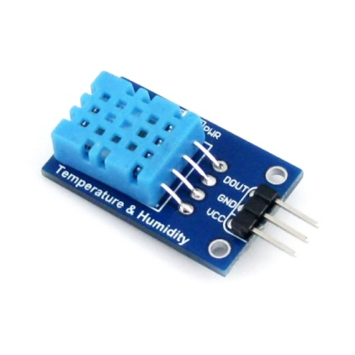

**Working:**

The DHT11 sensor operates based on the principle of capacitive humidity sensing and temperature measurement. Here's a simplified explanation of how it works:

1. Humidity Sensing: Inside the DHT11, there is a humidity-sensitive capacitor that changes its capacitance based on the ambient humidity. When the air around the sensor becomes more humid, the capacitance of this component increases, and conversely, it decreases when the air is drier.
2. Temperature Measurement: The DHT11 also contains a thermistor, a type of temperature sensor. The thermistor's resistance changes with temperature variations. As the temperature rises, the resistance decreases, and as it falls, the resistance increases.
3. Signal Conditioning: The DHT11 sensor has an integrated signal conditioning circuitry that converts the changes in capacitance and resistance into digital signals that can be read by a microcontroller. This circuitry also includes a microcontroller for processing the sensor's data.
4. Digital Communication: The DHT11 communicates its measurements to a microcontroller via a single-wire digital interface. This interface utilizes a simple and well-defined protocol to transmit both temperature and humidity data.
5. Data Retrieval: To obtain the readings from the DHT11, a microcontroller sends a start signal to initiate the measurement process. The sensor then responds by transmitting the temperature and humidity data in a specific format, usually in the form of 8-bit integral and fractional parts for both temperature and humidity.
6. Calculation and Display: The microcontroller receives and decodes the data from the DHT11 sensor and can then convert it into human-readable values. These values can be displayed on an LCD screen, sent to a computer, or used for various control purposes within a project.

The DHT11 sensor's straightforward design and digital interface make it easy to integrate into electronics projects, providing accurate and real-time temperature and humidity measurements for a wide range of application

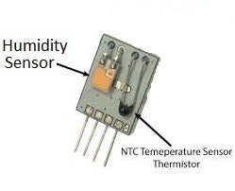

**DHT11 Sensor Interfacing with Raspberry Pi:**

Interfacing a DHT11 sensor with a Raspberry Pi is a valuable step in harnessing real-time environmental data and enhancing the capabilities of your projects. The DHT11 sensor, designed for temperature and humidity measurements, can be easily connected to the Raspberry Pi's GPIO pins. With the support of Python libraries, you can efficiently read and process the sensor's output, enabling the Raspberry Pi to provide accurate temperature and humidity readings. This integration is particularly useful for a wide range of applications, from building a home automation system that optimizes climate control to creating IOT weather stations that monitor local weather conditions in real time. The Raspberry Pi's computational power and versatility, coupled with the DHT11 sensor's precision, make this combination a powerful tool for anyone exploring environmental sensing and data-driven applications. DHT11 sensor interfacing with the Raspberry Pi offers a platform for innovative projects and opens up the possibilities for applications that rely on accurate climate information, making it a fundamental skill for those interested in IoT, automation, and environmental monitoring.

Integrating a DHT11 sensor with a Raspberry Pi is a pivotal step toward leveraging real-time environmental data and expanding the capabilities of your projects. The DHT11 sensor, designed for precision temperature and humidity measurements, can be effortlessly connected to the GPIO pins of the Raspberry Pi. With the extensive support of Python libraries, you can efficiently read and process the sensor's output, allowing the Raspberry Pi to furnish precise and up-to-the-minute temperature and humidity data. This integration holds immense value for diverse applications, from developing a smart climate control system that adapts to environmental conditions to establishing an IOT-powered weather station that provides constant monitoring of local weather conditions. The Raspberry Pi's computational prowess, versatile connectivity options, and the DHT11 sensor's accuracy make this collaboration an indispensable tool for makers, developers, and enthusiasts delving into environmental monitoring and data-centric projects. DHT11 sensor interfacing with the Raspberry Pi is not just about gathering climate information; it's about empowering you to utilize this data for a broad spectrum of innovative applications, making it an essential skill for those engaged in IOT, home automation, and data-driven environmental analysis.

